**Name: A. Shiva Surya Saran**

**Roll No.: BE-B 20**

**High Performance Computing**

**Assignment 4**

**Unit 4: Analytical Model of Parallel Program**

1. *Explain the basic Analytical Models with sources of overhead in Parallel Programs.*

***Basic Analytical Models***

* A sequential algorithm is evaluated by its runtime (in general, asymptotic runtime as a function of input size).
* The asymptotic runtime of a sequential program is identical on any serial platform.
* The parallel runtime of a program depends on the input size, the number of processors, and the communication parameters of the machine.
* An algorithm must therefore be analysed in the context of the underlying platform.
* A parallel system is a combination of a parallel algorithm and an underlying platform.

***Sources of Overhead in Parallel Programs***

Several overheads, including wasted computation, communication, idling, and contention cause degradation in performance.

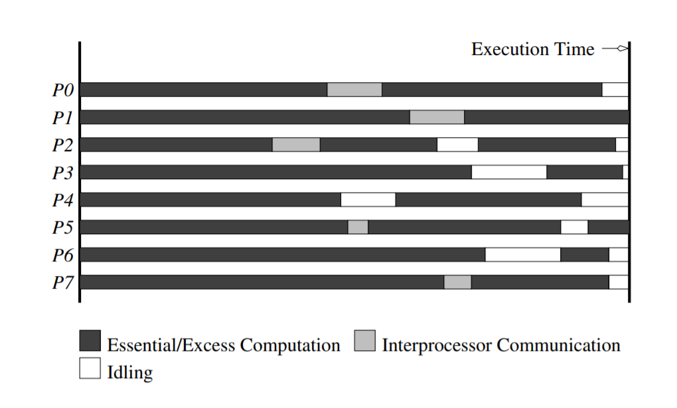

The execution profile of a hypothetical parallel program executing on eight processing elements. Profile indicates times spent performing computation (both essential and excess), communication, and idling.

Inter-process interactions: Processors working on any non-trivial parallel problem will need to talk to each other.

Idling: Processes may idle because of load imbalance, synchronization, or serial components.

Excess Computation: This is computation not performed by the serial version. This might be because the serial algorithm is difficult to parallelize, or that some computations are repeated across processors to minimize communication.

2. Describe the effects of Granularity on Performance.

* Using fewer processors often improves performance of parallel systems.
* Using fewer than the maximum possible number of processing elements to execute a parallel algorithm is called scaling down a parallel system.
* A naive way of scaling down is to think of each processor in the original case as a virtual processor and to assign virtual processors equally to scaled down processors.
* Since the number of processing elements decreases by a factor of n/p, the computation at each processing element increases by a factor of n/p.
* The communication cost should not increase by this factor since some of the virtual processors assigned to a physical processor might talk to each other. This is the basic reason for the improvement from building granularity.

3. Explain the Scalability of Parallel System with Amdahl’s Law.